Tomentosus Root Disease (Inonotus tomentosus) DRT
High to Medium priority
Description
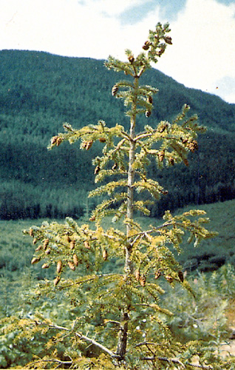
Interior spruce is highly susceptible. Moderately susceptible species include: lodgepole pine, western hemlock, Sitka spruce, Douglas-fir, and sub-alpine fir. Resistant or immune species include western redcedar and broadleaf species. Tomentosus root rot often causes small gaps in stand canopies that can coalesce into larger openings, within which lay randomly-oriented, downed trees with decayed roots. Symptoms include chlorotic thinning foliage, reduced shoot growth, and distress cones. Tomentosus causes a pink to red-brown stain in wood, which progresses to a salmon colour, eventually forming a honeycomb-like, white pocket rot. This pattern progresses from the interior of the root outwards. Decay can be found 1 to 2 m up the bole. Fruiting bodies are produced in the late summer directly from infected roots, and appear as small mushrooms (<10 cm across), which are leathery, velvet topped, and tan to brown, with a porous underside.

Extent
Tomentosus is the most prominent root disease in central and northern BC. Juvenile trees die quickly. Older trees suffer extensive butt rot leading to increased susceptibility to windthrow and insect attack. Tomentosus spreads primarily through root contact and can survive in infected large stumps for decades. Tomentosus is one of the most damaging diseases of spruce in the Kispiox, and is considered a high priority forest health factor. Tomentosus is a medium priority forest health factor in the Bulkley/Cassiar TSAs.
Although the FLNRO inventory appears to account for the mature volume loss in its yield model VDYP (OAF 2), this volume loss estimate illustrates the potential for increased stand productivity if Tomentosus is proactively managed. The impact of Tomentosus on the productivity of second growth stands is being investigated. It is hoped that more accurate Operational Adjustment Factors (OAFs) for root disease may be developed.

Data
- See map at the end of this section.
- The Bulkley TSR3 (2011) contained an unsalvaged loss estimate for Tomentosus, however, Pests of Young Stands (POYS) (e.g. hard stem rusts, leader weevils) and Tomentosus occur sporadically in Bulkley plantations. In the absence of localized loss data, losses towards maturity due to POYS, and decreased growth attributable to Tomentosus, are assumed to be accounted for through a 5% Operational Adjustment Factor (OAF2) applied to TIPSY yield curves.
- Kispiox Studies conducted prior to Kispiox TSR2 estimate annual unsalvaged volume of 52,000 m³/yr due to Tomentosus. As part of TSR2, a review of VDYP demonstrates that these losses are factored into VDYP yield estimates and as such, no additional volume reductions are required. Operational adjustment factor reductions for Tomentosus in managed spruce leading plantations are being refined. These refinements may lead to increases in OAF2 reductions for managed stands which may be examined through sensitivity analysis if the updated information becomes available within the TSR schedule.

Tactics
- In the Bulkley or Cassiar TSAs follow the strategies and tactics for Tomentosus root disease management outlined in the FPC Root Disease Management Guidebook or consult Regional MFLNRO experts.
- For the Kispiox TSA, follow the Tomentosus Root Disease Management in the Kispiox document attached in Appendix X. This document outlines the extreme risk of planting spruce in the Kispiox if the Tomentosus centres are not pre-identified.
FPC Root Disease Management Guidebook http://www.for.gov.bc.ca/tasb/legsregs/fpc/fpcguide/root/roottoc.htm

